Program Counter Testbench

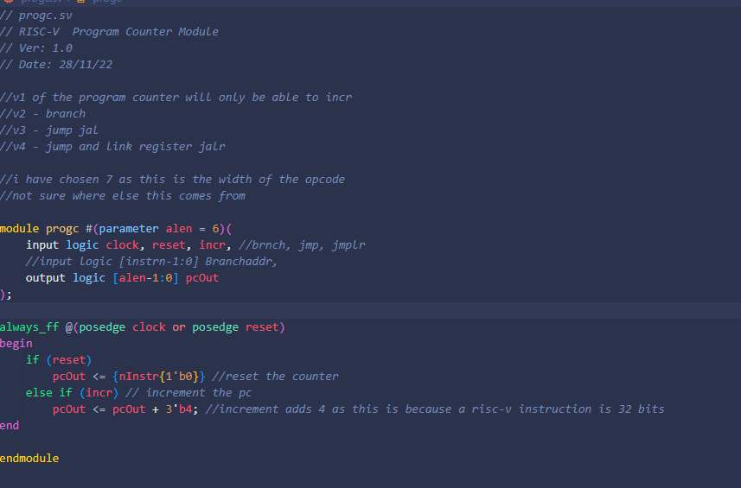

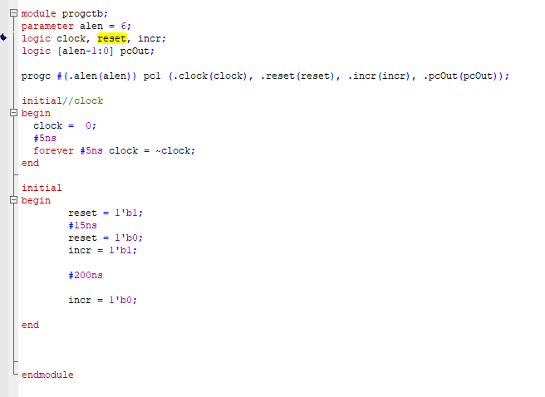



Program counter test bench checks that the cpu correctly increments,

This is shown in the waveform shown below as pcout increases by 4 each clock.